Home Work 1: Oracle SQL Class

Table of Contents
Home Work 1: Oracle SQL Class 1
Table of Contents 1
1. Homework 1: SQL Code 2
ORDER OF OPERATIONS 2
When creating tables 2
When adding data 2
When deleting data 2
2. Homework 1: ER Diagram for Music Database 3
3. Homework 1: Confirmation 4

Homework 1: SQL Code

ORDER OF OPERATIONS

When creating tables
  - Create the parent first (if more than 1 then either one)
  - Create the primary key on the parent
  - Create the child
  - Create the primary key on the child
  - Create the foreign ley on the child that points to the primary key on the parent

When adding data
- Add the parent records first (if more than 1 then either one)
- If more than one parent exists add the next parent record
- Then add the child record using the primary key values from parent/parents

When deleting data
- Delete the child record first
- Then you can delete one or more parents if you need to in whichever order you like

Homework 1: ER Diagram for Music Database

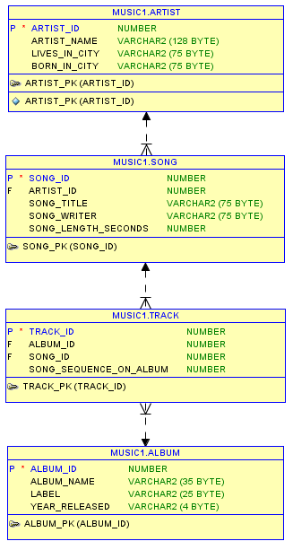
Artist is parent to Song
Song is child to Artist
Song is parent to Track
Album is parent to Track
Track is child to Song
Track is child to Album

Homework 1: Confirmation
Create a Microsoft Word document called HW1_Confirmation.doc.
Copy and paste the following SQL snippets into SQL developer after you have loaded your data for your music database.
Start by copying your queries y into your confirmation document.
Run the first query. It will produce a query result in the bottom right window. Using your mouse slide over all of the cells in the SQL Developer output window to select the output, then press CTRL-C. Then move your mouse over the Microsoft Word window and click CTRL-V. (don’t worry if you do not paste the column headings or row numbers—just the data is fine)
Email me the HW1_Confirmation.doc before Thursday night’s class.
-- ---------------------------------------------------
-- Homework No. 1 Confirmation
-- ---------------------------------------------------
-- 1. Question. List the artist’s names
select artist_name
from artist;
-- Copy and paste this SQL with the results from SQL Developer
-- into a Word doc
-- ---------------------------------------------------
-- 2.Question. List the song titles and artist's name for every
-- song you have and sort the list by song title
select artist_name, song_title
from artist ar, song s
where ar.artist_id = s.artist_id
order by song_title;
-- Copy and paste the SQL with SQL Developer results into the
-- same Word doc as No.1
-- ---------------------------------------------------
-- 3.Question. List the album name and song titles for each album
-- and sort by album_name
select album_name, song_title
from song s, track t, album al
where s.song_id = t.song_id
and t.album_id = al.album_id
order by album_name;
-- Copy and paste the SQL with SQL Developer results
-- into the same Word doc as No.1
-- ---------------------------------------------------
-- 4.Question. You are tryihng to decide if you want to
-- buy another album from an artist you already have
-- in your collection.
-- So list artist_name, album_name, song_title for every album
-- you have for that artist.
-- I will use Cher. Change Cher in the following query
-- to an artist in your database. Remember the artist name
-- must be the same case as your data in the table
select artist_name, album_name, song_title
from artist ar, song s, track t, album al
where ar.artist_id = s.artist_id
and s.song_id = t.song_id
and t.album_id = al.album_id
and artist_name = 'Cher';
-- Copy and paste the SQL with SQL Developer results into the Word doc
-- ---------------------------------------------------

